SIMATS ENGINEERING (SAVEETHA SCHOOL OF ENGINEERING)
Department of Computer Science and Engineering

ASSESSMENT TOOL 1 – Coding Challenge Task
Course Code: | CSA06 | Course Title: | Design and Analysis of Algorithms
CO Assessed: | CO4: Articulation (BL4, BL5) | Assessment: | Assessment Tool 1 – Coding Challenge Task
Weightage: | 40% of CIA | Total Marks: | 100
CO4 Statement: | Solve optimization problems using dynamic programming and greedy strategies.
Student Name: | SRINIVASAN A | Reg. No.: | 192411025
Section / Batch: | 2024/CSE | Date: | 22.08.2026

Instructions

to

Students

•

Answer

the

following

question.

Total

Marks:

100.

•

Carefully

analyze

the

given

questions.

•

Write

clear

code

for

the

given

problem.

•

Analyze

the

Time

complexity

and

Space

complexity

of

your

code

using

dynamic

programming

and

greedy

strategies

Question Type | Focus Area | Questions
Coding Challenge Task | Focus on Code and analyze optimization problems using dynamic programming and greedy strategies | Q1

SECTION A – Coding Challenge Task Code of Conduct
I

SRINIVASAN

SAN

A

-

192411025

(
Name

/

Reg

No)

certify

that

this

submission

is

my

original

work

and

that

I

have

adh
ered

to

the

guidelines

specified

for

this

assessment.

I

understand

that

any

violation

of

academic

integrity

rules

will

result

in

disciplinary

action.

Signature

of

the

Student:

SRINIVASAN

SAN

A

RUBRICS FOR CALCULATION

Coding Challenge Task
Criteria | Weightage | Level 4 (Exemplary) | Level 3 (Proficient) | Level 2 (Developing) | Level 1 (Beginning)
Problem Understanding | 20% | Clearly understands  problem  constraints, edge cases, and  competitive requirements | Understands  problem with  minor gaps in  constraints | Partial understanding; misses key constraints | Misinterprets problem or constraints
Algorithm | 25% | Selects optimal algorithm with  best time and space  complexity for  competitive  constraints | Uses efficient algorithm with  minor scope for  improvement | Uses basic/inefficient approach | No clear algorithmic  approach
Code Implementation | 20% | Writes correct, efficient, and  clean code that passes all constraints | Code works with minor errors or inefficiencies | Partially correct code; fails for some cases | Code does not execute or gives incorrect results
Competitive  Performance | 20% | Solves problem within time limits and  handles large inputs effectively | Solves within acceptable time with minor delays | Struggles with time limits or larger inputs | Unable to solve within time  constraints
Test Case  Handling | 15% | Handles all test cases including edge and hidden cases | Handles most test cases | Misses important edge cases | Fails on multiple test cases

Marks Evaluation:
Criteria | Wt. | Level 4 –  Exemplary | Level 3 –  Proficien  t | Level 2 –  Developing | Level 1 –  Beginning
Problem Understanding | 20%
Algorithm | 25%
Code Implementation | 20%
Competitive Performance | 20%
Test Case Handling | 15%
Total Marks (100):

Faculty In-charge | Course Coordinator | Head of Department
Name: | Name: | Name:
Signature: _______________ | Signature: _______________ | Signature: _______________
Date: ___________________ | Date: ___________________ | Date: ___________________

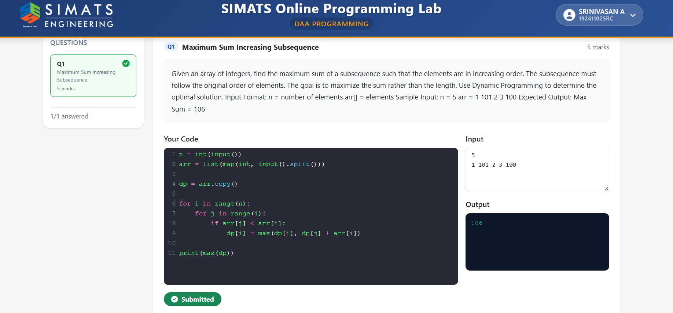

Algorithm: Maximum Sum Increasing Subsequence
- Start
- Read the number of elements n.
- Read the array arr[ ].
- Create a DP array dp[ ] and copy all elements of arr into it.
- For each element i from 0 to n-1:
  - Check all previous elements j from 0 to i-1.
  - If arr[j] < arr[i], update:
dp[i] = max(dp[i], dp[j] + arr[i])
- Find the maximum value in dp.
- Print the maximum sum.
- Stop
Example:
arr = [1, 101, 2, 3, 100]
Maximum Sum Increasing Subsequence = 1 + 2 + 3 + 100 = 106
Time Complexity: O(n²)
Space Complexity: O(n)

